Email-Notification :

-----------------------------------

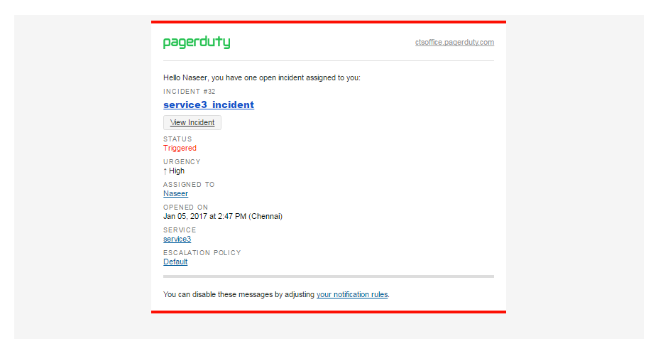

1. Incident Trigger

----------------------------

Old Message :



New Message :

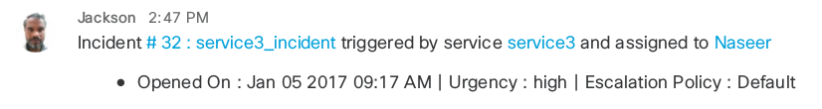

2. Incident Acknowledge

-----------------------------------

Old Message :



New Message :

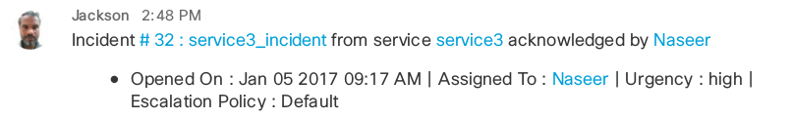

3. Incident Resolve

----------------------------

Old Message:



New Message :

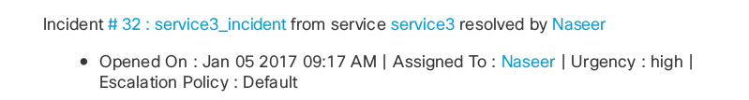

4. Incident manually Assign to user

---------------------------------------------

Old Message :



New Message :

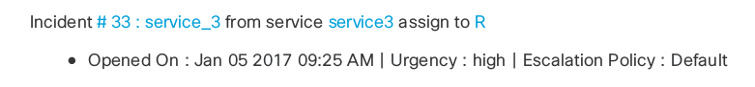

5. Incident Delegate :

-----------------------

Old Message :



New Message :

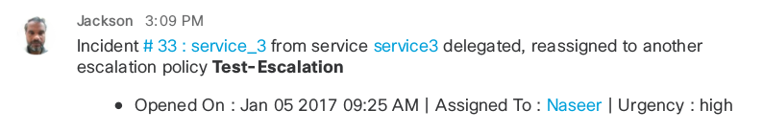

6. Incident Escalate :

-----------------------------

Old Message :



New Message :

